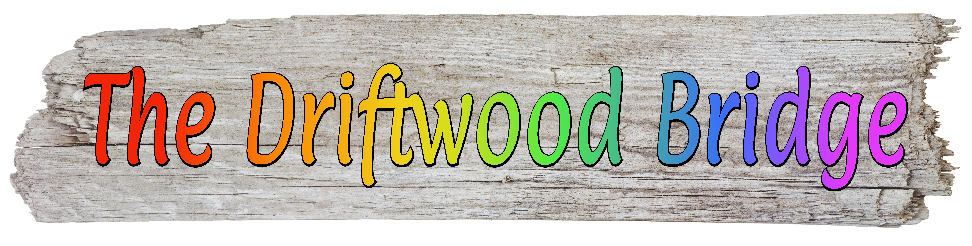

An original show about turning stumbling blocks into bridging materials premieres online

THE DRIFTWOOD BRIDGE: An Offering of Story and Song
Streaming on-demand through December 31, 2020 on www.driftwoodbridge.com
Free, with donations accepted
Pictures can be downloaded from www.driftwoodbridge.com/media-kit

Seattle, WA — “Do you ever feel like a castaway on the beach of life, marooned and left to do your best with whatever you can find on the shore? Knowing the mysterious tide that left you here will one day wash you away again? And the best you can hope for is to fill the uncertain time between with as much love as you possibly can?” So begins “The Driftwood Bridge.”

Like other theatre artists and performers around the world, David Mielke and Thomas Hitoshi Pruiksma had their plans overturned by the COVID-19 pandemic. Their original offering of story and song, “The Driftwood Bridge,” was supposed to run in Seattle for 5 weeks and has had to be postponed. But rather than bemoaning the show’s temporary fate, they’ve turned to presenting theatre in new ways, starting online with the free streaming premiere of a filmed version of the show’s most recent production. “People continue to tell us how much the show has meant to them,” Mielke said. “Since it touches on themes that have become even more relevant, we wanted to make it available in people’s homes.”

“The Driftwood Bridge: An Offering of Story and Song” is a two-person theatrical and musical memoir about taking experiences that wash up on the existential beaches of our lives and using them to build a bridge to carry us forward. The show explores life after loss, intergenerational forgiveness, and the ways mentors and friends help us feel ready to say yes to love—gay, straight, or otherwise. With Pruiksma on piano, each performer alternately tells their own story and sings songs—about letting go of old shame, learning to trust, and acknowledging the mystery of life. As with many rituals honoring what is known but unseen, the show bows to the joyful play of what seems to be serendipity.

“There’s a thread running through the show about openness to wonder, to the poetry of lived life,” Pruiksma said. “Our experiences may appear to be chaotic and random, but often there is some more mysterious pattern we can see or help to create that leads to unexpected gifts.”

To theatrically express the notion of these gifts, the performers construct a bridge out of driftwood. When the show opens, random pieces of driftwood lie scattered on the stage, each symbolizing a different life experience. As the show progresses, the duo fit all the pieces together, eventually forming a bridge.

“It’s a bridge that connects us,” Mielke said. “The idea is that we can see our negative experiences as stumbling blocks to trip over, or we can find a way to reimagine them into something positive to serve as steps to more kind, loving, and joyful lives. If nothing else, our difficult experiences can give us compassion.”

That transformation, Pruiksma said, has a healing power. It leads to changes in perception of ourselves and our world, which leads to taking new actions “and living more fully in line with our deepest hopes and highest intentions.”

The show is currently streaming for free on www.driftwoodbridge.com, where Mielke and Pruiksma are also showcasing another Covid-coping endeavor, a video series called “Broadway in the Yurt.” Recently featured in the Modern Love column of the New York Times, the series offers videos of beloved Broadway show tunes with a twist. Although it began simply as a means of creative expression, the series has turned out to be a way of deepening their relationship as they realized they could use the making of the videos to whimsically resolve issues of conflict that arose under the pressures of being cooped up in lockdown together.

“It’s our way to continue putting into action the things we explore in ‘The Driftwood Bridge,’” Mielke said. “The pandemic and the tumult of societal transformations are huge pieces of driftwood on our beach. There has to be a place for them in the bridge too.”

Contact:
David Mielke
david.s.mielke@gmail.com
9413 SW 171st ST
Vashon, WA 98070
(206) 261-2805

###

